Reviewing the Effect of Incarceration on Crime

By Mathias Gibson, December 2017

## **Introduction**

In order to explore the causal effect of incarceration on crime, I chose three well-regarded studies from time different periods: “The effect of prison population size on crime rates: Evidence from prison overcrowding litigation” by Steven D Levitt (1996), “More Time, Less Crime? Estimating the Incapacitative Effect of Sentence Enhancements” (2009) by Emily Owens, and “Incarceration and crime: Evidence from California’s public safety realignment reform” (2016) by Magnus Lofstrom and Steven Raphael. All three studies in this paper are forced to confront the simultaneity bias or reverse causality present in attempting to estimate the causal link between incarceration and crime. The causal direction between prison and crime is unclear if increased incarceration rates can be correlated with a decrease in crime due to increased incapacitation, while also being correlated with an increase in crime given that high-crime areas or periods will tend to utilize incarceration at greater rates. Does increased crime after increased incarceration say that incarceration causes crime, or that crime causes incarceration? While incarceration can affect crime by incapacitating the criminally active, deterring criminal activity, or transforming offenders by rehabilitating or hardening them, these studies all focus on the incapacitation effects. There is consensus in the studies that incarceration reduces crime rates, but they all differ in their estimates of the magnitude of the impact and reach different cost/benefit conclusions, as well as in the methodologies and policies that they exploit in order to estimate the causal link. The trends from these and other studies show a decreased impact for incapacitation as incarceration rates increase to include more marginal criminals, but the effects picked up by the studies are also vulnerable to broader socioeconomic trends.

## **1) Levitt (1996) “The effect of prison population size on crime rates: Evidence from prison overcrowding litigation”**

### Introduction

By 1994, the US prison population was over 1 million, with total costs reaching $40 billion annually, and an incarceration rate three to four times that of most european countries. Between 1973 and 1992, the incarceration rate tripled, violent crimes reported to the police per capita doubled and property crime increased by 30%. This study on the effect of incarceration on crime was conducted in 1996, at a time when 12 states had their entire state prison system currently or formerly under a federal court order due to overcrowding. Through studying the effect of overcrowding litigation on crime rates within these states, the study aimed to estimate the effect of prison populations on crime utilizing quasi-experimental methods.

### Design and Methodology

In order to eliminate the endogeneity or correlation with the error term in the link between incarceration and crime, this study uses the presence of overcrowding litigation and its arbitrarily timed changes on growth rates as an instrument to approximate the effect of incarceration on crime. Since overcrowding litigation affects the crime rate of states by causing incarceration to grow at relatively low rates, but crime rates aren’t predictive of overcrowding legislation, the simultaneity bias is removed and overcrowding litigation appears to be a viable instrument under the assumption that it is only affecting the crime rate through its impact on the incarceration rate, and not through any unobserved factors in the error term. Below is the two stage least squares (2SLS) regression derived using state overcrowding litigation as the instrument.



In this equation, Crime is per capita crime rate, Prison is per capita incarceration rate, s is a dummy variable for the status of overcrowding litigation, t is a dummy variable for year, X is a vector of covariates, 𝛾 is a vector of years, and β is the elasticity ratio of crime rate to incarceration rate, hence the use of logistic regression. Altogether, 11 total instruments were created using five overcrowding litigation status categories (filing the suit; receiving a preliminary court decision; obtaining a final decision from a judge; further court action such as appointing a special monitor; and release from court supervision) one year after change and two years after change.

### Results

The author finds the impact of prison populations on crime using 2SLS that is two to three times larger than previous OLS estimates, with elasticities of crime to incarceration of -0.4 for violent crime and -0.3 for property crime. According to these estimates, each additional prisoner leads to a reduction of 5.64 reported crimes, or 14.86 if extrapolating to include unreported crimes according to the estimate from victimization surveys that only 38% of all index crimes (forcible rape, robbery, burglary, aggravated assault, larceny over $50, motor vehicle theft, and arson) are reported. Given that prisoners per capita increased by 272% between 1971 and 1993, these results estimate that violent crime would be 70% higher and property crime 50% higher without the increase in incarceration.

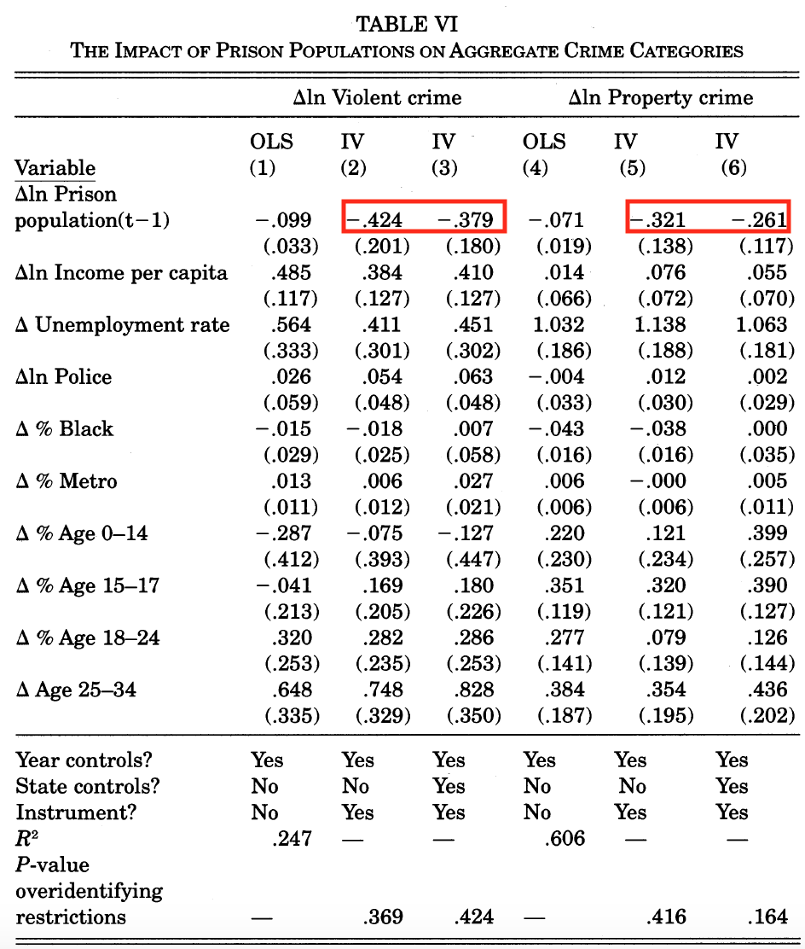

The cost/benefit analysis done in this study calculates the annual cost of a marginal prisoner as $30,000 per prisoner per year in 1996, as compared to a social cost of crime at $50,000 per prisoner per year. The cost of incarceration only includes the cost to the state, but not the cost of missing lost human capital, decline in post-release wages, pain and suffering for inmates and their families, or the cost of raising public revenue. The costs of crime include monetary costs such as medical bills, property loss, and productivity loss and quality of life costs estimated by civil suits, but are still missing some costs such as measures taken by victims, lifestyle changes, legal costs, and employer costs. The cost estimates are also only measuring seven categories, and missing crimes such as arson, drug offenses, and fraud. Ultimately the author’s conclusion is that the incarceration rate is properly calibrated since the costs and benefits are fairly even, though he acknowledges that this might not stand for the bottom quartile of offenders.

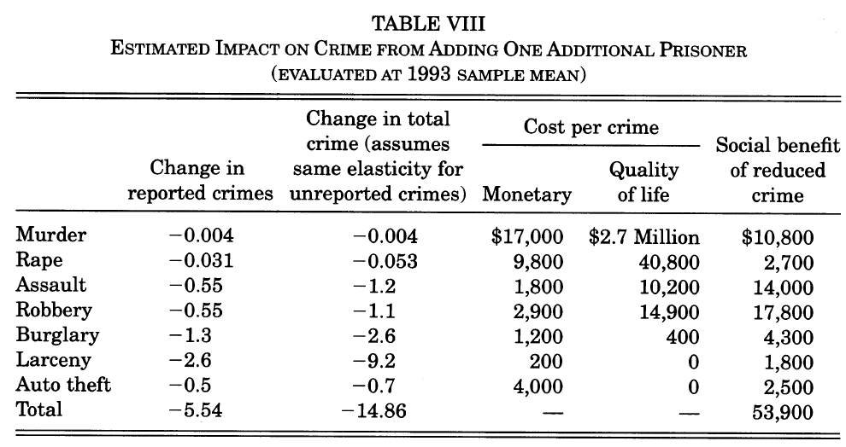

### Limitations and Validity

In extrapolating the estimates for reported crimes using victimization survey data, the author assumes that the elasticity of the crime rate to incarceration rate for reported data is the same as the elasticity for unreported data. However, I would expect that unreported crimes would tend to be less serious and in areas where crime is more common and persistent, and therefore result in a lower incapacitation rate and elasticity.

The greatest vulnerability in this study lies with the strength of the instrument. If overcrowding litigation did correlate with other factors that affect the crime rate such as decreased deterrence or motivation of law enforcement in the relevant areas, the impact of the litigation would be overstated. In instrumenting only for states where entire prison system is under court control, the sample is skewed to the south, and while the differences in incapacitation are not statistically significant, the results would understate the impact of incarceration on lowering the crime rate if incarceration did indeed have a lower impact in the south. At the very least the heteroskedasticity of the data implies that the residuals in the relationship between legislation and crime have a higher variance in smaller states, so the estimates should be weighted by state population. Finally, this study only looks at the causal impact of reducing prison population through litigation, and may not be valid in measuring the impact of policies that reform sentencing and prison inflow. Being 20 years old and based on time when the incarceration rate was higher and the average inmate age was lower make it hard to extrapolate the findings to today, as evidenced by decreased incapacitation effects found in the following studies.

## **2) Owens (2009), “More Time, Less Crime? Estimating the Incapacitative Effect of Sentence Enhancements”**

### Introduction

This 2009 study explores the impact of criminal incapacitation on the crime rate through the effects of sentence enhancement policies. These policies can take the form of mandatory minimums, three strikes laws, or, in this case, sentencing formula guidelines. The specific causal question being explored is how many crimes are actually prevented by extending prison sentences. The number of crimes prevented by an extended prison sentence should be equivalent to the number of crimes that the incarcerated offender would have commited were they free.

On July 1, 2001, the Maryland State Commission on Criminal Sentencing Policy reformed its sentencing guidelines to reduce the sentences of 23 to 25 year olds with juvenile delinquent records. Previous to this reform, recommended sentences were created using a formula that took into account adult criminal history, juvenile criminal history, history of parole violations, and relationship to the criminal justice system at the time of the offense to calculate a score with a maximum of nine, with a maximum of two points coming from the juvenile delinquent record. Offenders over 26 years old had their juvenile record excluded from this score. With the reformed guidelines for judges, the age at which juvenile delinquent records dropped from 26 to 23, effectively lowering the recommended sentences for the portion of this age cohort with juvenile delinquent records going forward.

### Design and Methodology

The author of this study tackles the endogeneity problem caused by the simultaneity bias between crime and incarceration by using the arbitrary variation in sentence length caused by sentence reform as an instrument in a quasi-experimental design. The crimes committed during the window of time in which formerly incarcerated individuals would have been incarcerated under the old guidelines serves as a proxy for the number of arrests that were averted by sentence enhancement prior to the 2001 reform.

The author first estimates the length of time defendants not serving enhanced sentences would have been incarcerated pre-reform by doing a difference-in-difference calculation between time served for former delinquents and the time served for non-delinquents pre and post-reform. However, since the average sentence length increased for those starting their sentences after the reform, time served couldn’t be accurately compared to sentence length due to sentences that were still in progress, and delinquent points could not be expected to equally affect the probability and length of sentence, a more complex estimation procedure was required. A two step estimation procedure was employed to calculate the extensive and intensive margins of the estimated period of time incarcerated, and coefficients were calculated by maximizing an adjusted negative binomial likelihood function.

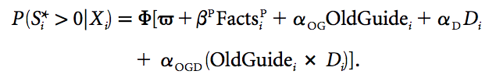

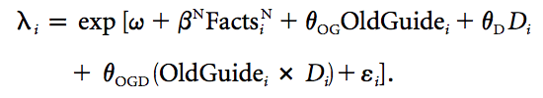

In the above regressions, OldGuide is a dummy variable that equals one if the sentence occurred under the old guidelines, D is the total number of delinquent points that the offender would have under the old guidelines, and Facts is comprised of the offender score minus delinquent points, the offense scores of the three most serious offenses, the total number of criminal acts for which the offender is convicted. The coefficients αOG, αD, and αOGD respectively represent the probability of incarceration associated with delinquent status, getting sentenced under the pre-reform guidelines, and having delinquent points in your offender score in the offender score.

### Results

Of the 73 former 23 to 25 year old delinquents whose sentences were shortened by the reform, 30% were arrested for a total of 102 crimes during the 164 day window in which they would have been incarcerated pre-reform. On average and per person, they had an arrest rate of 2.8 arrests per year, were prosecuted for two offenses and were involved in 1.4 to 1.6 serious crimes. Broken down by index crimes, 20% of the arrests accumulated are for assault or attempted murder, 4% for arson, and 3% for weapons violations. Approximately 17% of arrests are for property and general crimes (car theft, conspiracy, trespassing, and false statements to police).

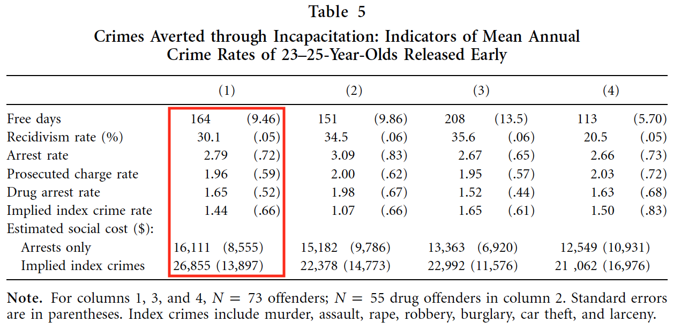

The author determines the net benefit of sentence enhancements to be between $1,150 and $14,600 per prisoner per year. These calculations are done differently than in the other two studies, estimating a substantial fixed cost for prison and arriving at a marginal annual cost per inmate that is less than half of the average cost. She also notes that the net effect of sentence enhancements only becomes negative in cases where the incapacitation is least beneficial and incarceration is most expensive.

However, similar to Lofstrom and Rafael (2016), the author also finds that the effect of incapacitation has decreased over time. Compared to previous estimates ranging from 12 to 187 crimes averted per year of incarceration, the 1.4 crimes averted in this study is notable. The author provides a few reasons for the difference: this study looks at offenders about to be released rather than the population as a whole, previous studies estimate incapacitation using past criminal behavior and overestimate the recidivism rate, the criminal population she studies is older than peak criminal years, and finally that the overall drop in crime rate may be due to fewer per capital crimes rather than fewer criminals.

### Limitations and Validity

While the instrument in this study is well-defined for the experiment, there are potential sources of bias that might decrease its reliability strength. The possible effect of decreased deterrence on crime rate could still be present, even though the author states that no mention of the change in guidelines was covered by media outlets. There is also the possibility that judges were compensating for the change in guidelines in other ways. Finally, since incarcerated criminals may be simply replaced while incarcerated, which is especially likely for drug crimes and other gang-related activity, this study may overestimate the impact of incapacitation.

## **3) Lofstrom and Raphael (2016), “Incarceration and crime: Evidence from California’s public safety realignment reform”**

### Introduction

The most recent of the three studies explores the impact of incarceration on crime rates through the 2011 California Public Safety Realignment, implemented on October 1, 2011. Assembly Bill 109, the legislation that created the realignment policy, was preceded by a long period of prison overcrowding in California that eventually resulted in two major lawsuits against the state for inadequate health care services and mental health services. Under the threat of a federal court order to release up to 20% of their prison population, AB 109 was passed and the state prison population dropped by 17% over the following year, with the population moving back to 1991 levels at 348 per 100,000 residents. AB 109 created a classification of non-violent, non-serious, and non-sexual offenders that would serve their sentences in county jails rather than state prison going forward, and stopped sending technical parole violators back to prison. In addition, this class of offenders would earn good behavior credit at a faster rate than in prison and can be given split sentences that include alternative monitoring with the general population.

The casual question that this study seeks to answer is whether counties with larger declines in incarceration rates have relatively large increases in crime rates, by attempting to isolate the variation in crime rate that can be attributed to realignment. The study also looks at whether California as a whole had an increase in crime following realignment, relative to the other 49 states that didn’t implement realignment plans over the same period. These questions are both an attempt to answer the larger question of whether incarceration leads to a decrease in the crime rate.

### Design and Methodology

By employing three different designs, this study is able to compare the robustness of the results while addressing limitations and biases that may exist. The first design is a simple ordinary least squares (OLS) regression that adds pre-post realignment change in crime rates as the dependent variable, county fixed effects (αi) to adjust for within-county variation, month fixed effects (βt) to adjust for trends in variation over time, pre-post realignment change in state prison rate as the first predictor, and pre-post realignment change in county jail rate as the second predictor. The jail incarceration rate needs to be controlled for since in a previous paper the authors discovered a substitution rate between prison and jail of three to one, meaning that a three person reduction in prison rate resulted in a one person increase in the jail rate, mostly from felons moving to jails rather than parole violators moving to jails.

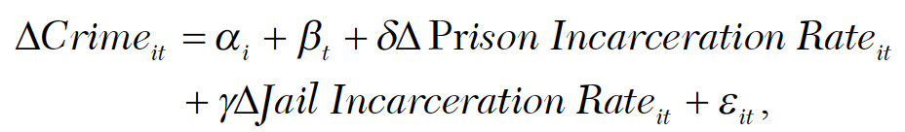

Since the explanatory variable of interest, incarceration rate, is correlated with the error term, which includes confounders such as previous attempts to address prison overcrowding that may have latent effects, the authors utilize a difference-in-difference design. The first difference is calculated by measuring the incarceration rate before and after implementation of realignment in October 2011 for each county in California, allowing them to account for inter-county variation and determine a pre and post-treatment effect. The second difference was in the time period, but the authors faced a dilemma since they wanted to select a narrow window of measurement so as to limit the chances of picking up confounding factors, but not so narrow as to fail to account for seasonal variation crime rate. To accomplish this, they subtracted the difference in crime rate for each month in 2012 from September 2011, and then found the difference between those results and the difference between each month in 2011 and September 2010. This allowed them to measure the variation in post-realignment crime rates relative to the last pre-realignment month of September 2011, and net out the differences that could be attributed to realignment by subtracting the result of the same procedure for a year prior.

To address concerns that focusing on county-specific effects is controlling away a statewide effect on deterrence caused by criminals changing their behavior after hearing about the publicized change in policy, the authors employed a synthetic controls design of the statewide effects of realignment relative to the other 49 states. Using data from the FBI’s Uniform Crime Report (UCR), the authors created a “synthetic California” consisting of a weighted average of states with similar crime trends to California before realignment, which would allow them to estimate a counterfactual scenario of how crime rates might have trended in California absent realignment. They then calculate placebo difference-in-difference estimates for each state as if they had experienced realignment at the same time as California in order to isolate the statewide impact for California. Given that California doesn’t have any major population centers bordering with other states, there was not concern about spillover of crime rate.

### Results

Table 3 shows the statewide change in crime rates between 2012 and 2011, 2011 and 2010, and 2012 and 2010. Between 2010 and 2011 all crime rates decline, with violent crime declining by 6.2% and property crime declining by 1.6%. Between 2011-2012, however, all crime rates increase, with violent crime increasing by 2.5% and property crime increasing by 6.6%. Finally, between 2010 and 2012, violent crime decreased by 3.9% while property crime increased by 4.9%.

Table 4 shows the estimates from different variations of the OLS regression. A maximum of 0.041 violent crimes per month were prevented for each prison year or 0.5 crimes per year, while a maximum of 0.183 property crimes per month were prevented each prison year, or 2.2 crimes per year.

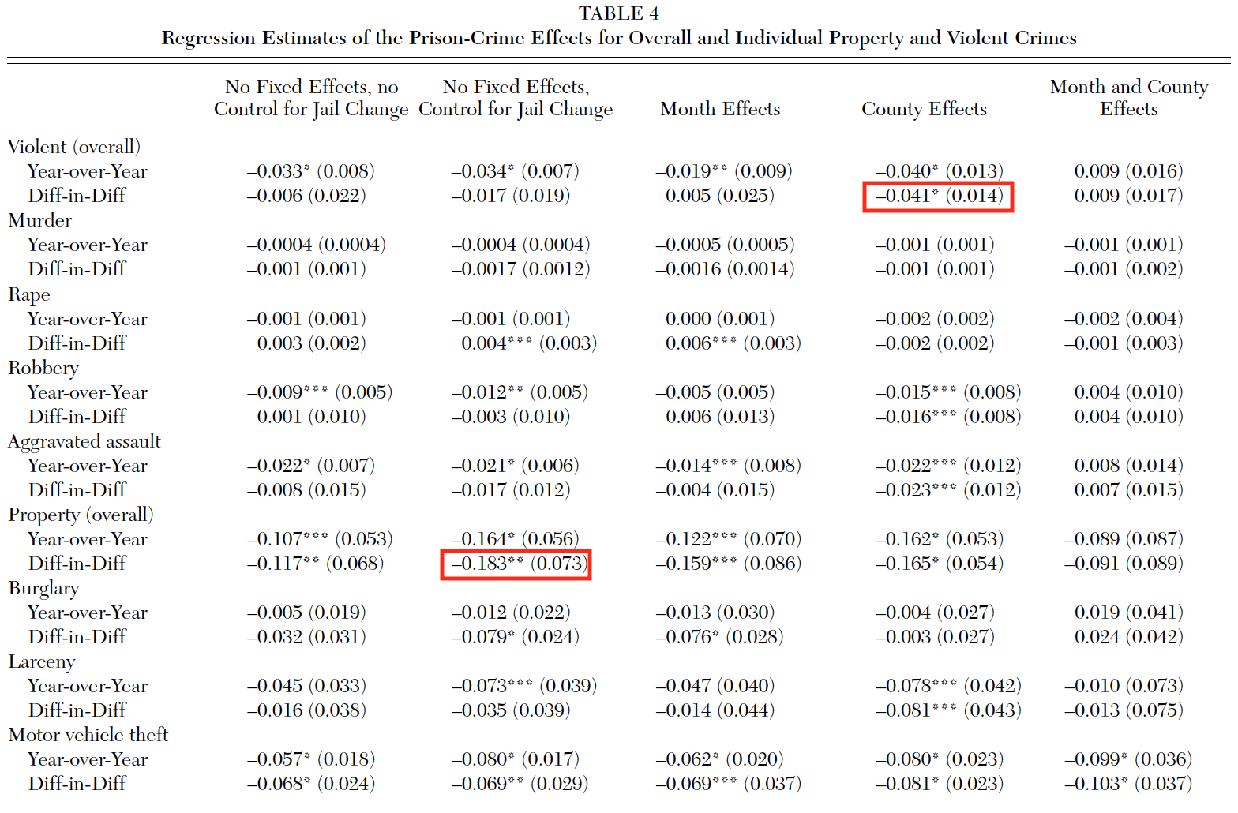

In figures 6 and 7, the results of the synthetic control design are shown for violent crime and property crime, respectively. The synthetic control creates a close match to the crime rate of the real California, and the placebo and real difference-in-difference results are not meaningfully different for violent crime, but the real California does have an uptick in property crime relative to the synthetic control, which is in line with the county by county results. The only statistically significant difference from this model is motor vehicle theft, which had by far the largest effect at a p value of 0.02. Based on a decrease of 60 incarcerated person per 100,000 residents between 2010 and 2013, motor vehicle thefts per 100,000 increase by 72% compared to synthetic CA, which is very close to the estimate in the county-by-county analysis.

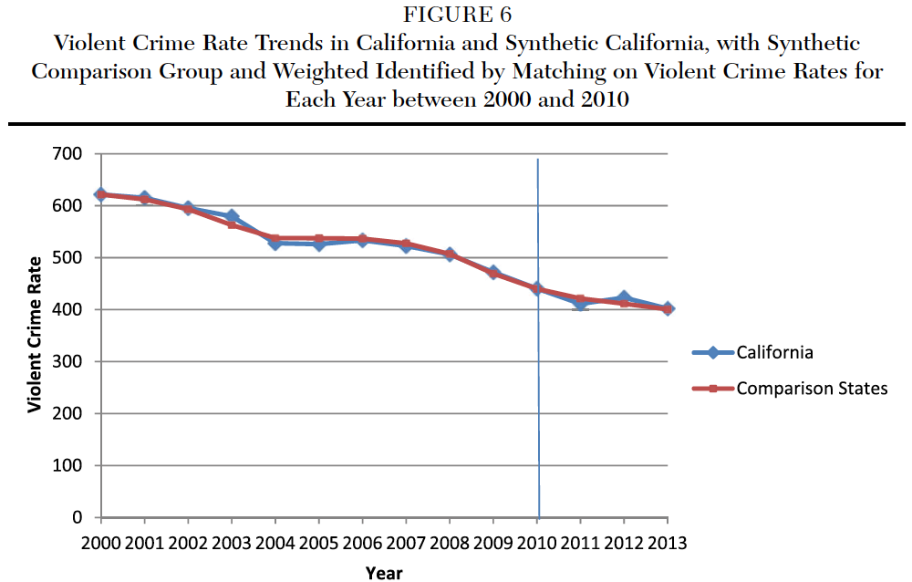

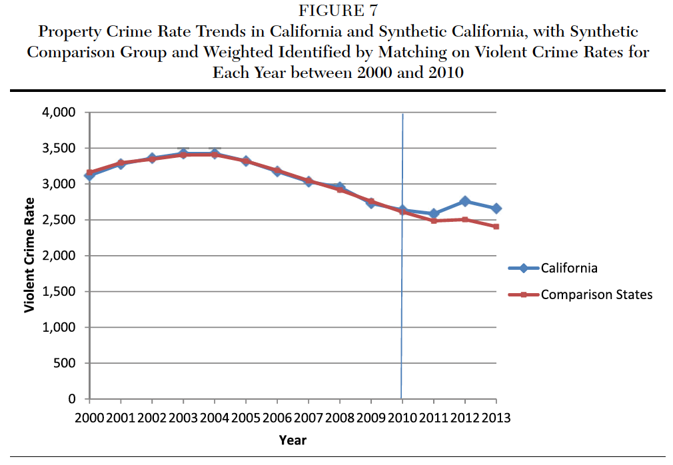

Finally, the cost benefit analysis for this study uses an estimated cost of incarceration per inmate of $51,889 and an estimated cost of motor vehicle theft of $9,553. Based on these figures, $11,783 in crime costs are prevented for each year served by those released due to realignment, which equates to a return of 23 cents for each dollar spent on incarceration for this group. The effect of incarceration on crime is much smaller than the first study, and the authors suggest that the effect may be due to diminishing returns to scale on incapacitation as more minor offenders are less likely to commit crimes upon release, along with the overall aging of the prison population.

### Limitations and Validity

The synthetic control design used in this study doesn’t show the distribution of crime rates for other states beyond California and “synthetic California”, making it difficult to compare whether California’s results are skewed to the extreme edge of the distribution. The instrument itself could have been catching the effect from larger confounding factors such as larger structural trends that decrease crime or regional trends that carry across borders such as gang activity and drug crime. Finally, its difficult to extrapolate the effects beyond the subgroup of non-sexual, non-serious, non-violent offenders that were released, since this is a population that is least likely to reoffend, which also helps explain the decreased impact on crime relative to other studies. California’s variety of reforms packaged with AB 109 as well as separate bills and initiatives also make it difficult to discern whether incapacitation was less effective, or whether alternative sentencing and interventions were more effective.

## **Conclusion**

Across the three studies, creative design methods are employed to estimate the impact of incarceration on crime rates. The first two studies use quasi-experimental designs with instrumental variables, while the third utilizes the difference-in-difference and synthetic control designs. In each case, an increase in crime is found as a result of the decrease in incarceration studied, but the more recent studies demonstrate a decreased return to scale dynamic with incarceration rates. As incarceration rates rise, prison populations will be comprised of a greater proportion of minor offenders, and the societal value of incapacitating these offenders is lower than the marginal cost of incarceration.

There still seem to be large gaps in knowledge about the impact of incarceration, however. One cause is the spotty data quality resulting from unstandardized data collection at the state and local level, and the limited detail of data at the federal level. Another is that definitions of terms continue to change, making it more difficult to study across time periods. Two of the studies mention police officers as a more cost effective tool for crime reduction than incarceration, while withdrawing to the claim that incarceration is the best penal tool available until more cost effective alternative solutions are proven to be effective. None of these studies spend much time discussing the social determinants of crime that underlie the effects that they are trying to measure, but rather treat crime as a problem with the individual, which is unfortunate. However, the null effects of California’s realignment policy may encourage further statewide prison reforms and provide more opportunities to study the impact of reduction in incarceration rates and alternatives.

## 

## **References**

Levitt, S. D. (1996). The effect of prison population size on crime rates: Evidence from prison overcrowding litigation. *Quarterly Journal of Economics*. https://doi.org/10.2307/2946681

Lofstrom, M., & Raphael, S. (2014). Incarceration and crime: Lessons from California’s public safety realignment reform. *CESifo DICE Report*, *12*(4), 40–46. https://doi.org/10.1177/0002716215599732

Owens, E. G. (2009). More Time, Less Crime? Estimating the Incapacitative Effect of Sentence Enhancements. *The Journal of Law and Economics*, *52*(3), 551–579. https://doi.org/10.1086/593141